Lab 3: Suppression

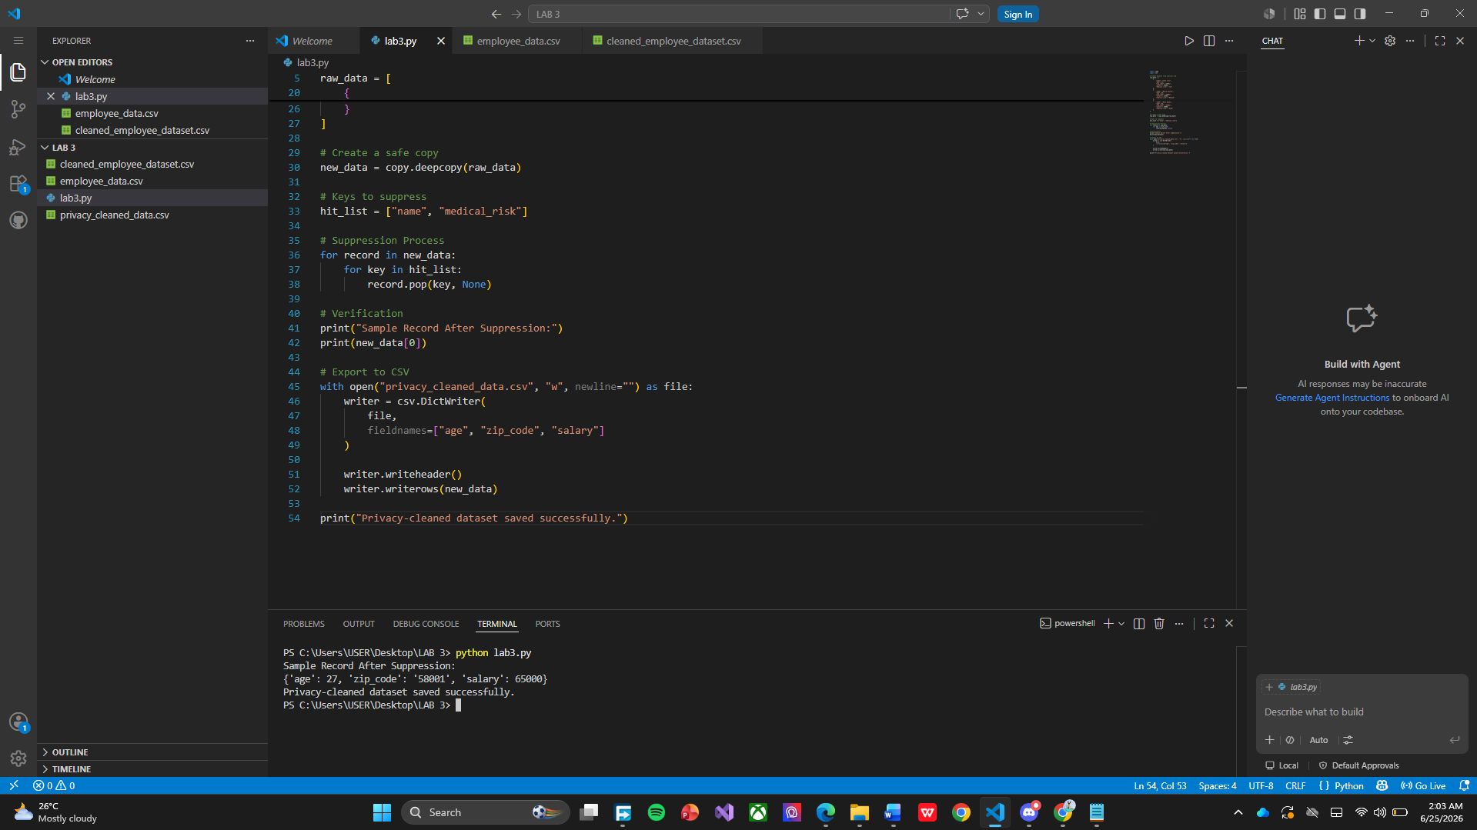

This program demonstrates the suppression technique used in data privacy protection. First, a copy of the original employee dataset is created using deepcopy() to ensure that the original data remains unchanged. The program then defines a list of sensitive fields, specifically name and medical_risk, which need to be removed from the dataset. Using nested loops, it goes through each employee record and safely removes these fields with the .pop() method. After the suppression process, the program prints a sample record to verify that only the non-sensitive attributes, such as age, zip_code, and salary, remain. Finally, the cleaned dataset is exported and saved as a new CSV file named privacy_cleaned_data.csv. The output shown in the terminal confirms that the suppression was successful because the displayed record no longer contains the employee's name or medical risk information. This process helps protect individual privacy while still preserving useful data for analysis and research purposes.

